Types of Virtual Networks:-
Virtual networking is analogous to traditional physical networking; still, in virtual networking, some or all of the tackle factors are replaced with virtual network factors composed of software.

1. Bridged Network-
A bridged network is a type of network where a virtual machine and its host are connected to the same network. In this setup, the virtual machine uses the host computer's Ethernet connection to connect to the main public network, commonly known as the internet.. Bridged networking works with both wired and wireless connections.

2. NAT Network
NAT, or Network Address Translation, is a process that translates IP addresses to enable connectivity between virtual machines and external networks. In a NAT network, virtual machines have their own private network created on the host computer. The NAT device on the network translates the information from virtual machines to the host machine's public IP address and forwards it to the correct destination.

3. Host-only Network
Host-only networking creates a private internal network for VMs to connect to, similar to a NAT network. This type of networking establishes a network connection between the virtual machine and the host computer using a virtual Ethernet appendage that is visible to the host operating system. It is beneficial when setting up an isolated virtual network.

Nat to Nat-


Bridged to Bridged-
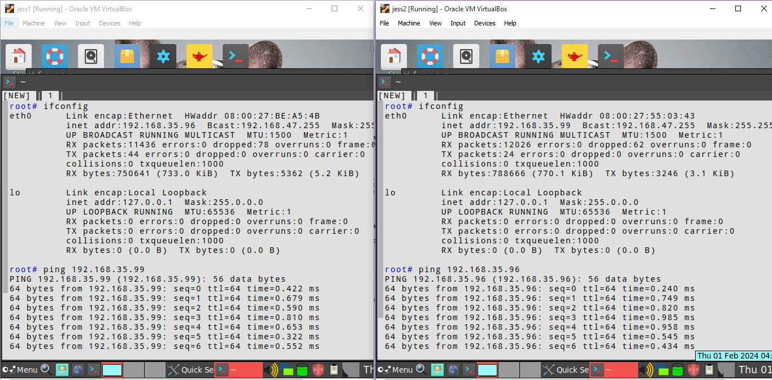


Nat to bridged -



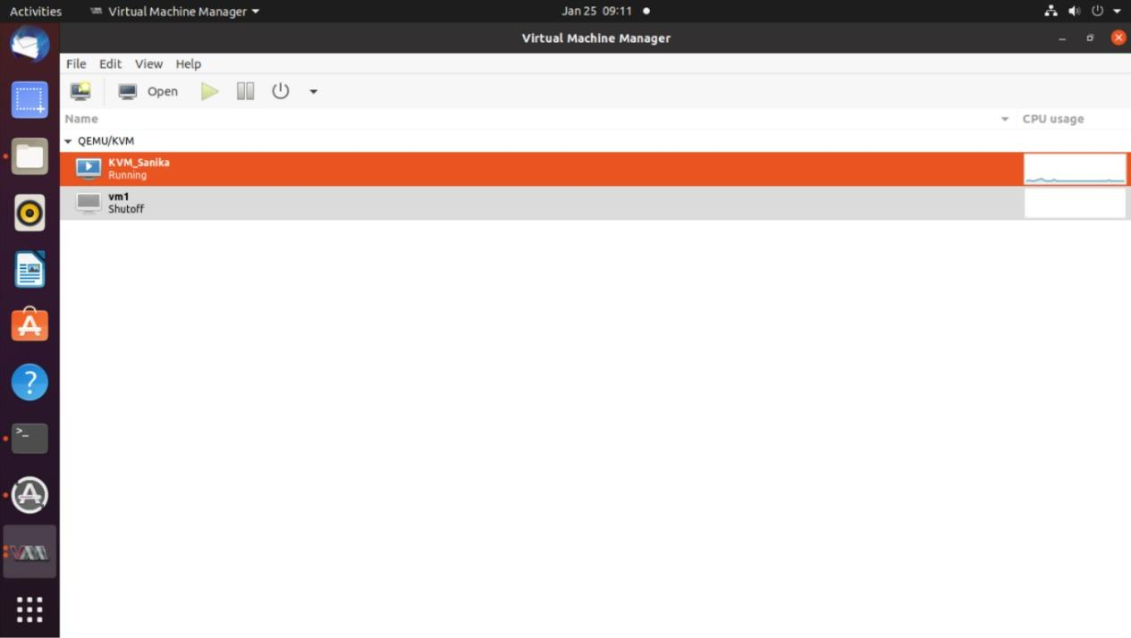

Conclusion:-
VirtualBox and KVM provide useful virtualization solutions with different features. Because it's an easy-to-use Type-2 hypervisor, VirtualBox is perfect for testing and desktop environments. KVM, on the other hand, performs best in server contexts with higher performance and resource efficiency because it is a Type-1 hypervisor built into the Linux kernel. KVM is useful for its benefits in performance and scalability, while VirtualBox is better suited for simplicity and convenience of use. The virtualization platform that an organization chooses must take into account many criteria such as technical competence, infrastructure size, and workload. Virtualization technology's adaptability enables companies to maximize their IT investments, improve operational effectiveness, and adjust to changing computing needs.

